Predictive Pulse: Harnessing Machine Learning for
Blood Pressure Analysis
Project Description

Predictive Pulse is a machine learning–based healthcare project designed to analyze and predict blood pressure levels using medical and lifestyle data. The system uses historical health data such as age, weight, heart rate, and cholesterol levels to train machine learning models. After preprocessing the data, algorithms like Logistic Regression, Decision Trees, and Random Forest are applied to predict whether a person's blood pressure is normal or at risk. The project helps in early detection of hypertension and supports better health monitoring through data-driven insights.
Project Scenarios
• Early Hypertension Detection
The system analyzes patient health data and predicts the risk of high blood pressure, helping doctors identify hypertension at an early stage.
• Hospital Patient Monitoring
Hospitals can use the model to analyze patient records and monitor blood pressure trends for better treatment decisions.
• Personal Health Tracking
Individuals can input their health data into the system to check their blood pressure risk level and take preventive measures.
Tech Stack
Backend : Flask (Python)
Frontend : Vanilla HTML/CSS/JS (Modern Aesthetics)
Machine Learning : Scikit-learn (Random Forest)
Data Processing : Pandas, Numpy
Project Structure
App.py : Main Flask backend handling routing and inference.
Train_model.py : Script for synthetic data generation and model training.
Verify_model.py : Utility to test model performance on edge cases.
Analyze_data.py : Data exploration script for source datasets.
Static : Contains CSS (style.css) and JavaScript (script.js).
Templates : HTML templates for the web interface.
Model.pkl & scaler.pkl : Serialized ML components.
Project Architecture:
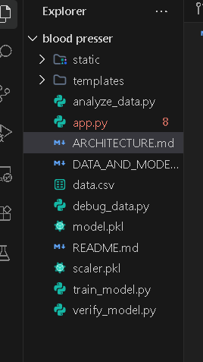

1. System Architecture Diagram
This diagram shows how the frontend, backend, and machine learning model interact.
┌──────────────────────────┐
│ User / Patient │
│ (Enter health data) │
└─────────────┬────────────┘
│
▼
┌──────────────────────────┐
│ Frontend │
│ HTML / CSS / JavaScript │
│ Web Form Interface │
└─────────────┬────────────┘
│ HTTP Request
▼
┌──────────────────────────┐
│ Flask Backend │
│ (app.py) │
│ - Input Validation │
│ - Data Processing │
│ - API Endpoint /predict │
└─────────────┬────────────┘
│
▼
┌──────────────────────────┐
│ Data Preprocessing │
│ - Scaling (scaler.pkl) │
│ - Feature Transformation │
└─────────────┬────────────┘
│
▼
┌──────────────────────────┐
│ Machine Learning Model │
│ Random Forest (model.pkl)│
│ Blood Pressure Prediction│
└─────────────┬────────────┘
│
▼
┌──────────────────────────┐
│ Prediction Result │
│ Normal / High Risk BP │
└─────────────┬────────────┘
│
▼
┌──────────────────────────┐
│ Result Display │
│ Frontend Dashboard │
└──────────────────────────┘

2. Machine Learning Workflow Diagram
┌─────────────────────┐
│ Health Dataset │
│ Age, Weight, HR, │
│ Cholesterol, etc. │
└──────────┬──────────┘
│
▼
┌─────────────────────┐
│ Data Preprocessing │
│ - Cleaning Data │
│ - Handling Missing │
│ - Feature Scaling │
└──────────┬──────────┘
│
▼
┌─────────────────────┐
│ Feature Selection │
│ Select important │
│ health indicators │
└──────────┬──────────┘
│
▼
┌─────────────────────┐
│ Model Training │
│ Random Forest │
│ Algorithm │
└──────────┬──────────┘
│
▼
┌─────────────────────┐
│ Model Evaluation │
│ Accuracy / Testing │
└──────────┬──────────┘
│
▼
┌─────────────────────┐
│ Save Model │
│ model.pkl │
│ scaler.pkl │
└──────────┬──────────┘
│
▼
┌─────────────────────┐
│ Deployment in Flask │
└─────────────────────┘

3. Data Flow Diagram (DFD – Level 1)
┌───────────┐
│ User │
└─────┬─────┘
│
▼
┌──────────────────┐
│ Input Health Data│
│ Age, HR, Weight │
└─────┬────────────┘
│
▼
┌──────────────────┐
│ Flask API │
│ /predict endpoint│
└─────┬────────────┘
│
▼
┌──────────────────┐
│ Data Processing │
│ Scaling & Encode │
└─────┬────────────┘
│
▼
┌──────────────────┐
│ ML Model │
│ Random Forest │
└─────┬────────────┘
│
▼
┌──────────────────┐
│ Prediction │
│ BP Risk Level │
└─────┬────────────┘
│
▼
┌──────────────────┐
│ Display Result │
│ on Web Interface │
└──────────────────┘

4. Project Folder Structure Diagram
Predictive-Pulse
│
├── app.py
├── train_model.py
├── verify_model.py
├── analyze_data.py
│
├── model.pkl
├── scaler.pkl
│
├── static
│ ├── style.css
│ └── script.js
│
├── templates
│ └── index.html
│
└── dataset
└── health_data.csv

Frontend Architecture
HTML5/CSS3 :Uses a glassmorphic design system with CSS variables for theming.
JavaScript :An asynchronous event-driven architecture using fetch() and DOM manipulation.
Responsive Layout :Designed to work on mobile, tablet, and desktop.
Backend Architecture
Flask API-Light :weight server handling routing and serving static files.
Endpoint/predict.Validation :Ensures input is numeric and within reasonable ranges.
Transformation :Encodes categorical data (Gender) and scales numerical data.
Inference : Uses the `sklearn` RandomForest model for classification.
Business Logic : Applies clinical thresholds (Hb / RBC) to provide human-readable interpretations.
Machine Learning Model Training Flow
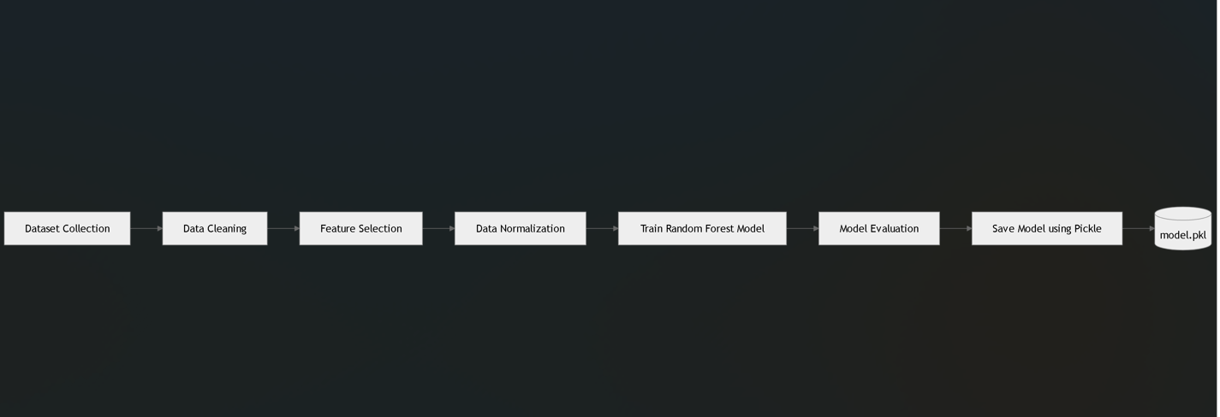

Project out put :
